**1.**

ALTER TABLE ACCTMANAGER

ADD ("Comm_id" NUMBER (2) DEFAULT 10,

"Ben_id" NUMBER (2));

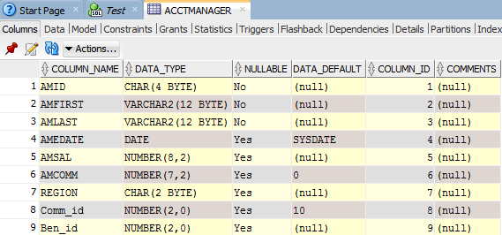

CREATE TABLE commrate

("Comm_id" NUMBER (2) DEFAULT 10,

"Comm_rank" VARCHAR(15),

"Rate" NUMBER (1,2));

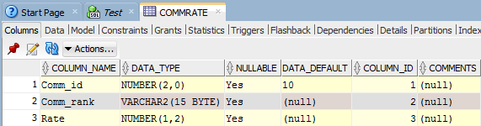

CREATE TABLE benefits

("Ben_id" NUMBER (2) DEFAULT 10,

"Ben_plan" CHAR(1),

"Ben_provider" NUMBER (3),

"Active" CHAR (1),

CONSTRAINT chk_active CHECK ("Active" = 'Y' OR "Active" = 'N'));

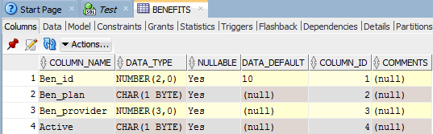

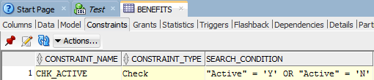

**2.**

CREATE TABLE project

("Proj#" NUMBER(10,2) NOT NULL,

"P_name" VARCHAR2(20) NOT NULL,

"P_desc" VARCHAR2(50),

"P_budget" NUMBER(9,2),

CONSTRAINT proj#_pk PRIMARY KEY ("Proj#"),

CONSTRAINT p_name_uk UNIQUE ("P_name"));

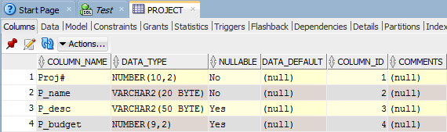

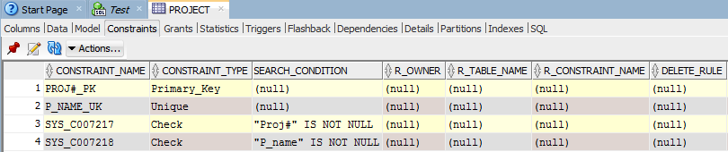

CREATE TABLE workorders

("Wo#" NUMBER(10,2),

"Proj#" NUMBER(10,2),

"Wo_desc" VARCHAR2(50) NOT NULL,

"Wo_assigned" VARCHAR2(20),

"Wo_hours" NUMBER(4) NOT NULL,

"Wo_start" DATE DEFAULT SYSDATE,

"Wo_due" DATE DEFAULT SYSDATE,

"Wo_complete" CHAR(1),

CONSTRAINT wo#_pk PRIMARY KEY ("Wo#"),

CONSTRAINT proj#_fk FOREIGN KEY ("Proj#")

REFERENCES project ("Proj#"),

CONSTRAINT wo_desc_uk UNIQUE ("Wo_desc"),

CONSTRAINT wo_hours_ck CHECK ("Wo_hours" > 0),

CONSTRAINT wo_complete_ck CHECK ("Wo_complete" IN ('Y','N')));

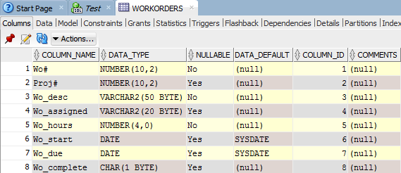

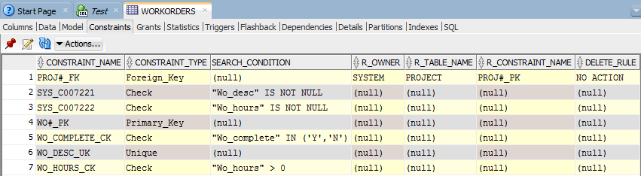

**3.**

CREATE TABLE CATEGORY

(CATCODE VARCHAR2(3) PRIMARY KEY,

CATDESC VARCHAR2(11) NOT NULL );

INSERT INTO CATEGORY VALUES ('BUS', 'BUSINESS');

INSERT INTO CATEGORY VALUES ('CHN', 'CHILDREN');

INSERT INTO CATEGORY VALUES ('COK', 'COOKING');

INSERT INTO CATEGORY VALUES ('COM', 'COMPUTER');

INSERT INTO CATEGORY VALUES ('FAL', 'FAMILY LIFE');

INSERT INTO CATEGORY VALUES ('FIT', 'FITNESS');

INSERT INTO CATEGORY VALUES ('SEH', 'SELF HELP');

INSERT INTO CATEGORY VALUES ('LIT', 'LITERATURE');

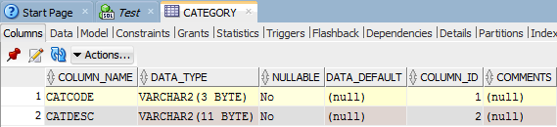

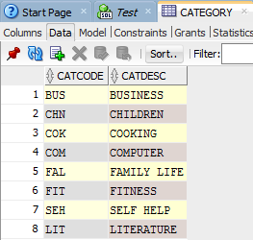

ALTER TABLE BOOKS

ADD("Catcode" VARCHAR (3));

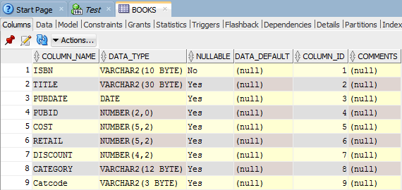

ALTER TABLE BOOKS

ADD CONSTRAINT catcode_fk FOREIGN KEY ("Catcode")

REFERENCES category(catcode);

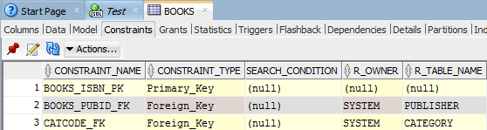

UPDATE books

SET "Catcode" = 'BUS'

WHERE category = 'BUSINESS';

UPDATE books

SET "Catcode" = 'CHN'

WHERE category = 'CHILDREN';

UPDATE books

SET "Catcode" = 'COK'

WHERE category = 'COOKING';

UPDATE books

SET "Catcode" = 'COM'

WHERE category = 'COMPUTER';

UPDATE books

SET "Catcode" = 'FAL'

WHERE category = 'FAMILY LIFE';

UPDATE books

SET "Catcode" = 'FIT'

WHERE category = 'FITNESS';

UPDATE books

SET "Catcode" = 'SEH'

WHERE category = 'SELF HELP';

UPDATE books

SET "Catcode" = 'LIT'

WHERE category = 'LITERATURE';

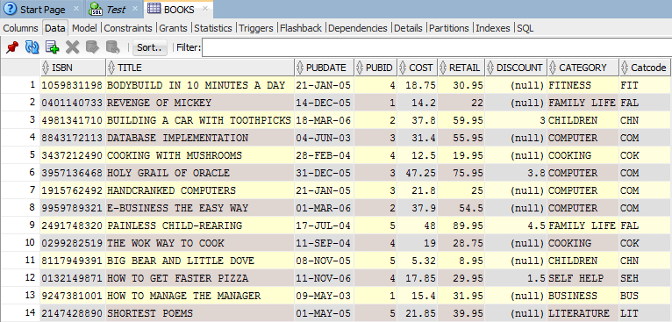

COMMIT;

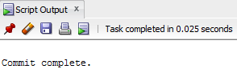

ALTER TABLE books

DROP column category;

